CHAPTER 1



**INTRODUCTION**

**1.1 Overview**

An application invoked in a web browser over the internet is called a Web-Application is. Since the birth of internet, it has become the launching pad for many sophisticated and innovative web applications. In the past it was used for accessing static websites mostly but nowadays dynamic applications are in common. New web technologies, standards and programming languages allow us to create dynamic web applications which create co-operation and collaboration among large number of users. Web application development can quickly adopt the software engineering techniques and its development is made easier with the help of **Microsoft Platform** whichalso termed as **frameworks.** These frameworks allow **Waterfall application development** by allowing development team to focus on the features of theirapplication that they are providing to the user without worrying about other details such as user management. Examples of web apps include simple office applications such as spreadsheets, word processors and online presentation tools. The advanced applications are also present like point of sales software, picture editing and drafting tools.

Internet has revolutionized today’s world especially in terms of Internet banking and money transfer, e-commerce etc. The advancement in internet has broadened the opportunities for business and professional development. The management systems ranging from a large industry to a small sales point are now computerized and web enabled as the access to internet is easier and more economical. The computerization process is reducing the paper work as it is easier to search for information and to manage records with computerized systems. Manual needs time and extra labor but computerized management and information portals are effectively handling the activities and they can even be customized according to the specific user requirements.

Few years back Chinese wanted to make Basketball team for South Asian Games. As we know that in general Chinese are not so tall. Hence, they used their national database to find which area has people above 6 ft height. They found it in Tibet Province and so they channelized their resources to develop players from there and eventually made a team that won them the Game. So this idea can be used to allow PN to channelize its efforts for different tasks especially bearing in mind the fact of its expansion w.r.t CTF, CMCP and CPEC. There is no system available to allow this kind of analysis.

The MIS for a company or an institution etc. are either developed or installed on individual systems or they are running on local intranet, only accessible within the institution or organization. There are various application packages over the internet which make **software as a service** over the web, hence, considerably reducing the software development andmaintenance cost which was not easy to afford for many small scale business vendors. Now with the increasing demand of data storage capabilities, different vendors are providing cloud services for efficiently storing the data for any need which is possible due to the rapid development in communication technology as well as internet speed. Storage of data over internet is in fact the most reliable because it enables easy recovery of data in case of any loss or damage. Despite the security concerns regarding hacking techniques, the advantages of this technology overweigh some of the disadvantages.

This technology can revolutionize the Recruitment field with regards to handling of Recruitment data report generation and analysis online. Although running software across internet is not a big deal, some major service providers are providing their services over a decade but use of software in process of recruitment is still lacks, especially in our country.

Our project **RAS** (Web enabled Dashboarding and Analytics System) is basically a web-based solution requiring no software to download or no hardware to purchase. Just a matter of seconds, the user, and the administrator can be registered and they can begin using the web services to enter, access and update user records, and get computer generated report of user data.

**1.2 Motivation**

There no requirement to go through each and every individual form in order to collect data or to manage user/employee records manually because RAS is fully automated system designed to provide user with advanced features to view this information and at the same time it provides management with birds eye-view of the reports of recruitments over major dimension and measures, most advanced BI technology of Microsoft Power BI is used to provide end user with high end analysis through various reports and graphical visuals. The Reporting Dashboard connected with live data shows up to date picture of recruitment for analysis over various perspectives.

**1.3 Objectives of the System**

* Automated Data Entry of Employee Records.
* Paper Less storage of employee data for fast and smooth process of Recruitment.
* Usercan view his profile information over one click of button
* Advanced reporting solution for Management.
* Easy management of User Records with central managed data repository.
* Live connected data warehouse to retrieve live data any time.

- Live Reports and Dashboards to provide advanced analysis of recruitment.

**1.4 Project Methodology**

* The requirement gathering from stake holders is always the first step. We have closely monitored current functionality in PN Recruitment System which needs many improvements, as all employee records are managed manually and no recruitment reports are available for management.
* On the Front end, C# as server side language. Web pages were designed using HTML, CSS and ASP Master Pages technology.
* There are six main Modules. They are Home, Enter Records, View Records, Edit Records, Analysis and User Management.

**1.5 Project Scope**

* RAS is built to provide advanced analysis of recruitments through dashboards and reports.
* It consists maximum employee information which is stored in central database
* Data stored by web application may be used further for data mining or for any other statistical analysis.

**1.6 Project Summary**

**Project Title:** RAS: The DSS for Recruitment

**Project Start:** 10September 2017

**Project Finish:** 10 May 2018

**Project Summary:**

**RAS** is fully automated system designed to provide user with advanced features to view his information at the same time it provides management with hawk eye view of recruitments reports over major dimension and measures, most advanced BI technology of Microsoft Power BI is used to provide end user with high end analysis through various reports and graphical visuals. The Reporting Dashboard connected with live data shows up to date picture of recruitment for analysis over various perspectives.

**Software Platforms/Languages:**

C#, HTML, CSS, ASP Master Pages and IIS Server.

**Integrated Development Environments:**

MS SQL (For Database Modeling and Schema and to be used as Database Server) SQL Configuration Management.

**Hardware:**

No hardware has been used yet for development

**Project Supervisor:**

Lt Waqas PN

**1.7 High Level Project Plan**

|  |  |  |  |  |  |  |
| --- | --- | --- | --- | --- | --- | --- |
| **Activities/Milestones** |  |  |  |  | **Date** | |
|  |  |  |  |  |  | |
|  |  |  |  |  |  | | |
| Proposal Submission |  |  |  |  | September 2016 | |
|  |  |  |  |  |  | |
|  |  |  |  |  |  | | |
| Proposal Approval |  |  |  |  | January 2017 | |
|  |  |  |  |  |  | |
|  |  |  |  |  |  | | |
| Requirement Specification |  |  |  |  | May 2017 to July 2017 | |
|  |  |  |  |  |  | |
|  |  |  |  |  |  | | |
| Higher Level Design |  |  |  |  | February 2018 | |
|  |  |  |  |  |  | |
|  |  |  |  |  |  | | |
| Problem Classification Design |  |  |  |  | 3rd Week of April | |
|  |  |  |  |  |  | |
|  |  |  |  |  |  | | |
| Development/ Prototyping |  |  |  |  | May 01, 2018 on wards |
| *Table 1.7 High Level Project Plan* |  |  |  |  |  |

CHAPTER 2



**LITERATURE REVIEW**

1. **An Introduction to the Scripting Languages**
2. ***What is a scripting Language***

A Computer language which is used in conjunction with other programming languages like Java, C++ or HTML etc. and normally run inside a web browser is called a Scripting language. Perl, Python, PHP, VBScript, ASP.net, and JavaScript are all examples of scripting language.

Scripting language can be of Client side and of Server side. **Client side scripting** languages are those in which scripts execute in browser on user side. E.g.Java Script, Visual Basic. Client side programming is mostly done with Java script in addition with HTML and CSS. **Server Side Scripting** languages are those in which scripts execute on server side on Applicationservers. E.g. PHP, C#. Server side scripts run the HTML page is loaded and not after.[2] [3] [4]

**2.2 Comparison of different Scripting Languages**

1. ***ASP.net***

ASP is supplied with Microsoft .net framework which is an easy to learn scripting language. [1]

1. <html>
2. <head>
3. <title>ASP.NET Hello World Demo</title>
4. </head>
5. <body>

6.

7. <% Response. Write ("Hello World!") %>

1. </body>
2. </html>

Chapter 3



**METHODOLOGY AND IMPLEMENTATION**

* + 1. **An Introduction to the Scripting Languages**

Every software Project normally contains following steps:-

1. **Project Planning and Proposal Writing**
2. **Software Requirement Gathering**
3. **Design**
4. **Development**
5. **Integration and Testing**
6. **Installation and Deployment**

These steps are simple and straightforward but there is risk in case of failure. Hence, Waterfall Application Development architecture for software development was introduced.

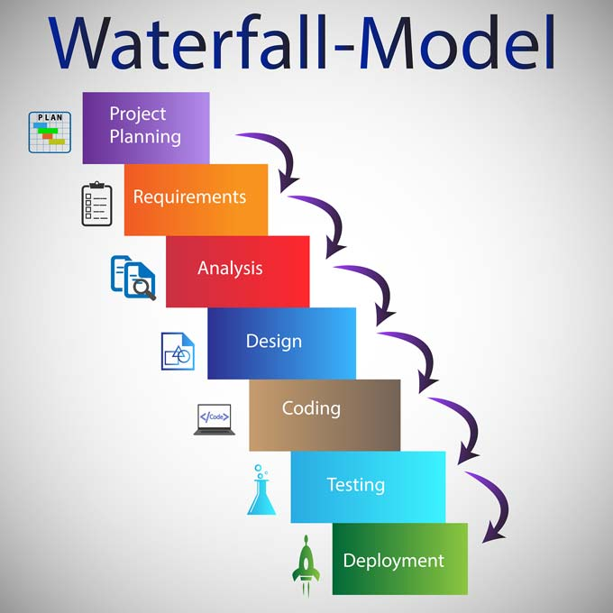

Figure 2: (Waterfall Application Development Model)

As seen in the figure, it is an incremental development process. Rails Framework also follows this development process.

**3.2 Project Planning**

The part of Project Management concerning the use of schedules e.g. Gantt charts and timeline to demonstrate starting and ending date within the project environment is called the Project Plan. RAS was intended to be launched as Software as a Service to facilitate the proper maintenance of recruitment data of PN in order to allow Report generation based on this data.

Following diagram shows our basic planning of the project:-

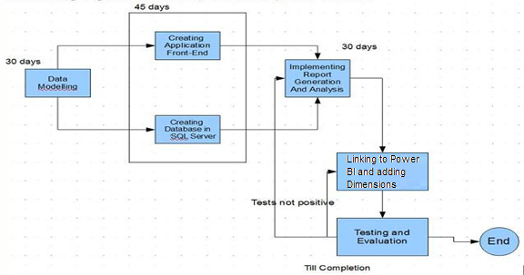

*Figure 3: Project Plan*

The need for software and hardware platform was determined which was a web server, database and visual studio software for front end development. Plan was made for efficient communication of group members over social network, whatsapp and weekly meetings to synchronize the work throughout the development phase.

At the end, the following initiatives were planned and consulted with the supervisor:-

* + Implementation should begin with Database Modeling which will be as generic as possible
  + Web Application should be developed using a latest technology especially for learning purposes
  + There should be weekly meeting among group members for project initiation

**3.3 Software Requirements**

Software Requirements is basically the complete description of the software; how it works, use cases which describing user-software interaction. Before development RAS we collected all functional and non-functional requirements from the recruitment centers as they can tell best about the whole problems and requirements which are important for the Software. The software requirements specification document enlists all the necessary requirements for the project development. To derive the requirements we require clear and thorough understanding of the products to be developed. This is prepared after detailed meetings with the project team. To automate current process in the first step and then use the stored data for analysis using Power BI platform.

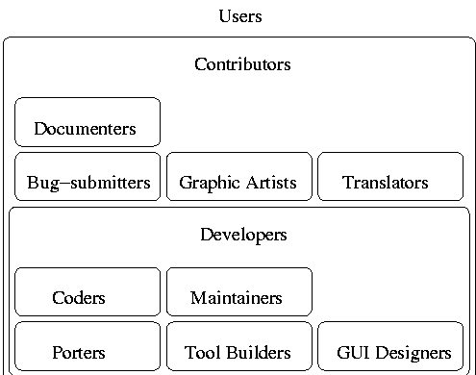

Table 3.3 Roles in Software Development

Stake Holders in the Project:-

* Project Supervisor: Lt Waqas PN
* Development Project Leader: S/Lt Muhammad Danyal Khan PN
* Requirement Analyst: S/Lt Usman Saif PN
* Front End Developer:S/Lt Danish Farhan PN
* Back End Developer:S/Lt Raja Talha PN
  1. **Design**

*3.4.1 Database Life-Cycle*

Data base design was the first step of development of our software. It has to be very strong and powerful and generic because it has to have maximum information of PN Recruits. We have developed database model on MSSQL Database which easy to maintain and secure as compare to other databases. [4] [5] [6] [7]

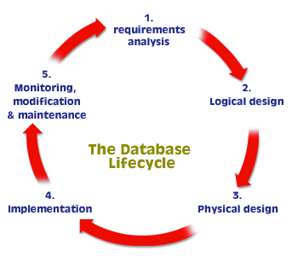

Figure 4: Database Life Cycle Process

*3.4.2 Data Modeling*

The process of data modeling starts with the selection of the main entities that will play role in The organization. Thus, a basic Entity-Relationship Diagram as shown in the figure on the following page was developed.

The Blocks in the diagram represent a “Relation” or an “Entity” in the database while the lines containing connectors show relationship among them. This is the part of Conceptual Database Design used to map the structure of database for our application.



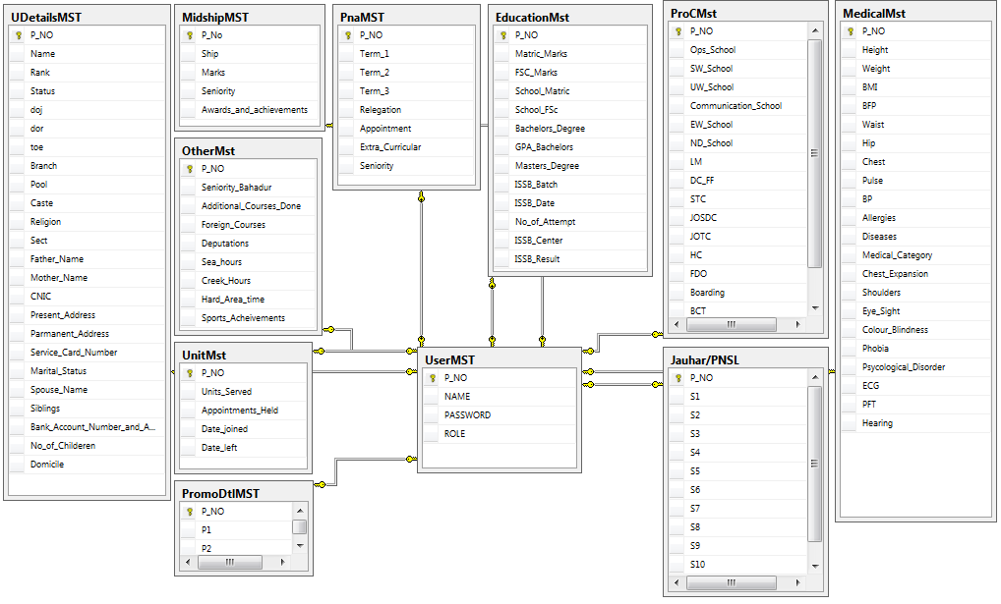

Figure 5: Data Modeling

**3.5 High Level Design**

The Web pages are designed in HTML, Java Script, CSS and PHP. HTML is for the basic page layout as girders set the layout of ceilings. CSS is for enhancement of color, pop-ups etc. ASP.net is for Client side data verification process and C# for the rest of the back-end coding.

* + 1. *Modules*

Six main modules of our application are as follows:

* Main Page
* Enter Records
* View Records
* Edit Records
* Insert User
* Analysis

Chapter 4



**GRAPHICAL USER INTERFACE AND SOFTWARE USAGE**

There are six Modules developed so far and we are increasing our functionality each day.

**4.1 Main page:**

This is the front page of our project RAS. Here, all the modules links are available through which the user can access his/her required Module.

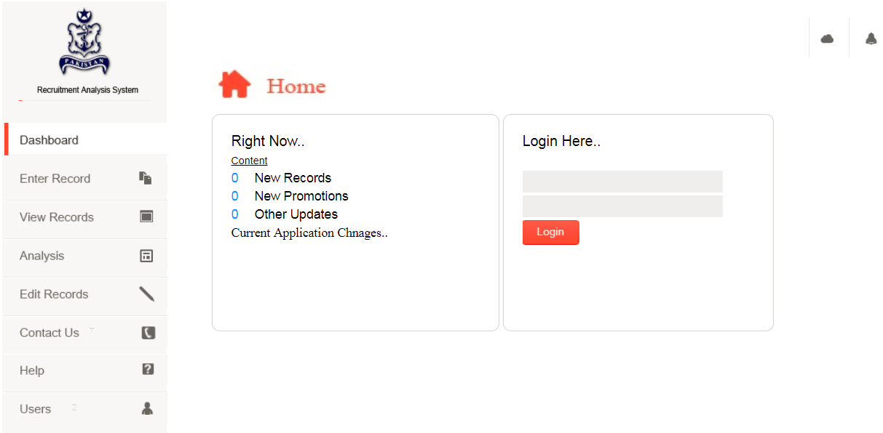

Figure 6: Main Page

**4.2 Enter Records**

In this module admin can insert complete information of the recruit; Primary Details, Medical Info, Educational Info, Basic Information, Courses information, Job Role, Rank, Employee Promotion details, Location, Units and etc.

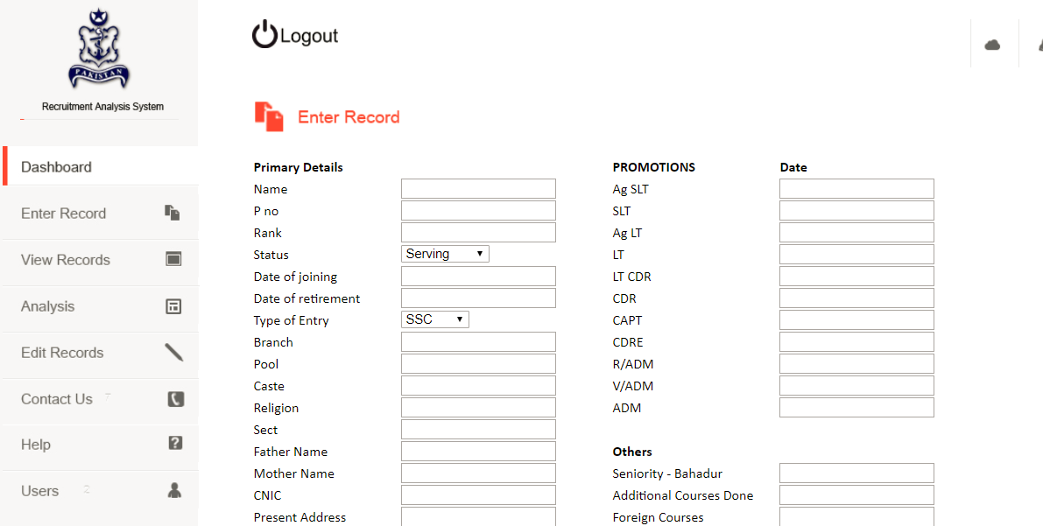

Figure 7: Enter Records Module

**4.3** **View Records.**

In this Module user or admin can view the recruit’s information; Primary Details, Medical Info, Educational Info, Basic Information, Courses information, Job Role, Rank, Employee Promotion details, Location, Units and etc. User just have to enter PNO and press search button to retrieve all the information.

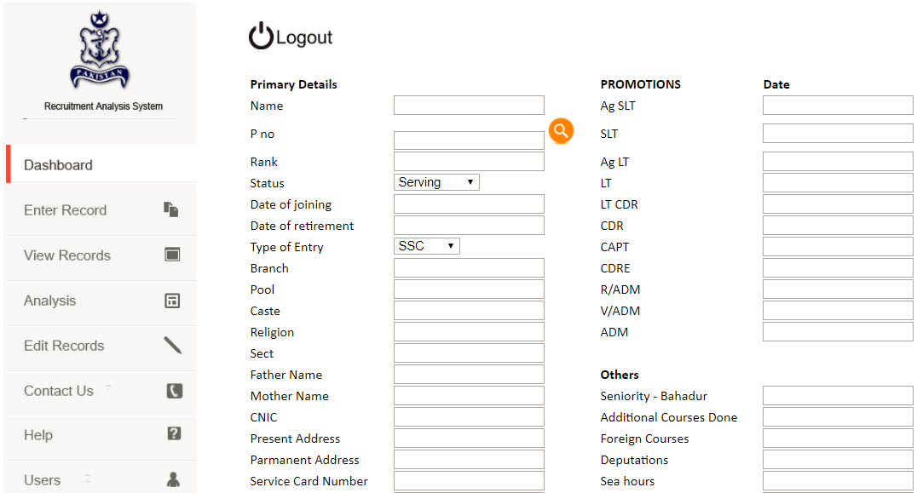

Figure 8: View Records Module

**4.4 Edit Records:**

Here, the recruit’s information can be Modified; Primary Details, Medical Info, Educational Info, Basic Information, Courses information, Job Role, Rank, Employee Promotion details, Location, Units and etc. User just have to enter PNO and press search button to retrieve all the information then update it and press update button.

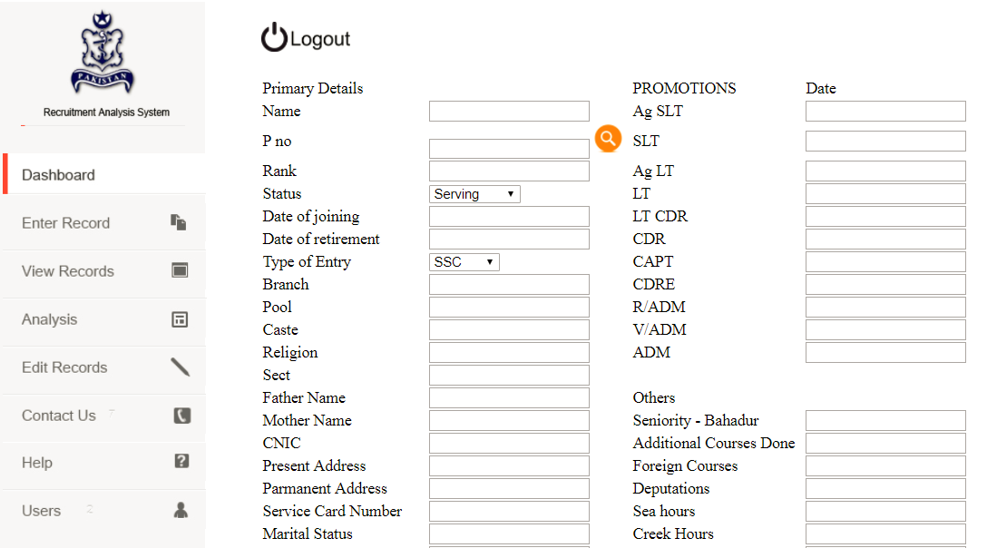

Figure 9: Edit Records Module

**4.5 Insert User:**

From this page, admin can add new user. New user must be added before entering the recodes which is pre-defined functionality of the system.

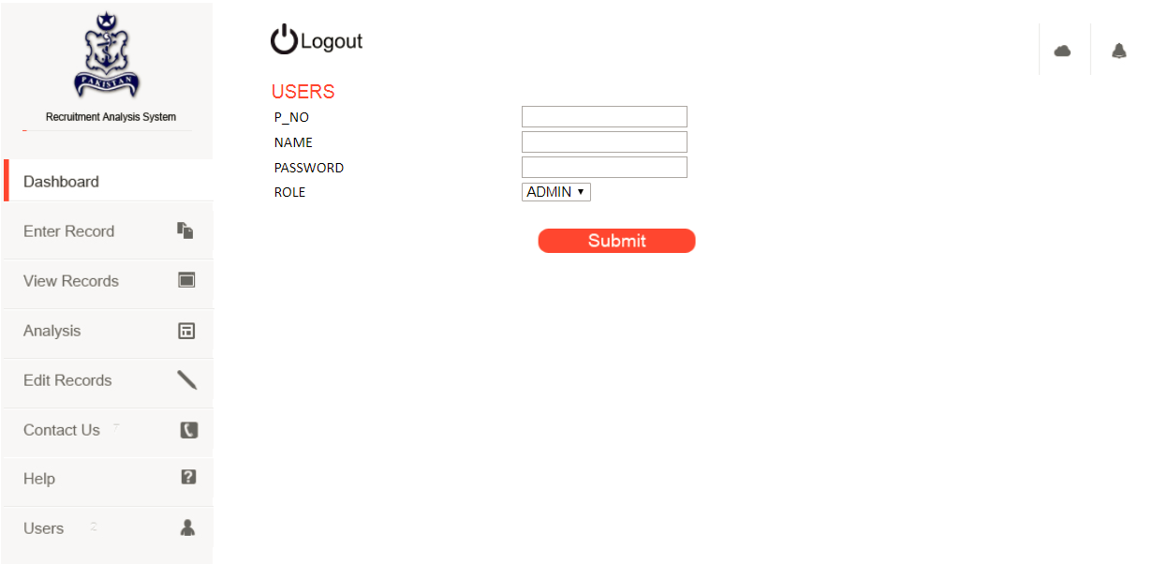

Figure 10: Insert User Module

**4.6 Analysis**

This is the primary part of the application, i.e. the integration with Microsoft Power BI platform and provide multi-dimensional charts, graphs and bars based on live recruitment data stored by admin by entering records in order to aid in Analysis. [8]

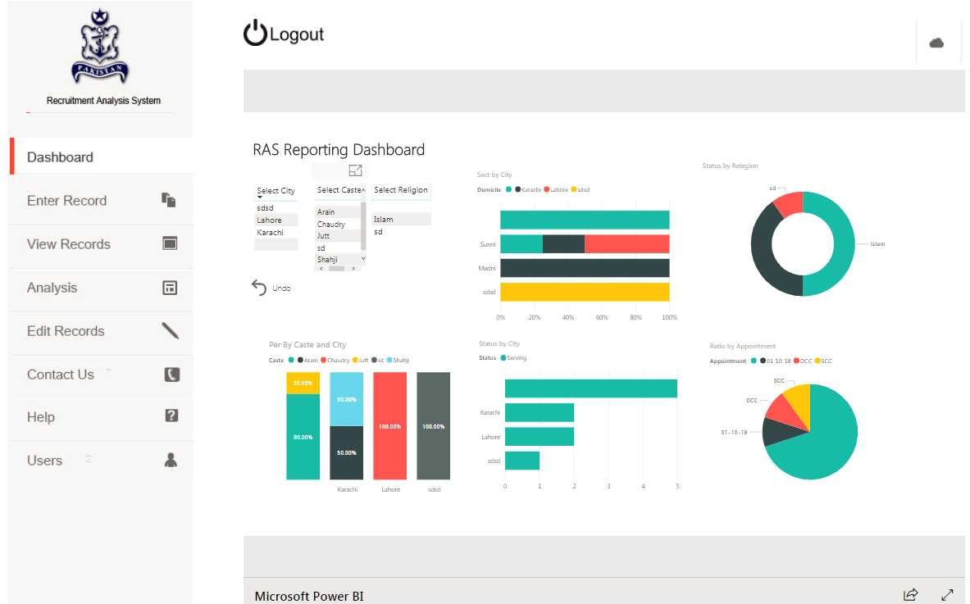

Figure 11: Analysis Module

Chapter 5



**SUMMARY AND LIMITATIONS**

**5.1 Summary**

Our project RAS: The DSS for Recruitment is a web-based Dash boarding and analytics system that has no requirement of software to download or no hardware to purchase. Just a matter of seconds, user, and admin can be register and start using the web services to enter, access and update recruit’s records.

There is no need to go through every individual form to collect data or to manage user/employee records manually. RAS is fully automated system designed to provide user with advanced features to view his information at the same time it provides management with birds eye view of recruitments reports over major dimension and measures, most advanced BI technology of Microsoft Power BI is used to provide end user with high end analysis through various reports and graphical visuals. The Reporting Dashboard connected with live data shows up to date picture of recruitment for analysis over various perspectives.

The MIS for a company or an institution etc. are either developed or installed on individual systems or they are running on local intranet, only accessible within the institution or organization. There are various application packages over the internet which make **software as a service** over the web, hence, considerably reducing the software development andmaintenance cost which was not easy to afford for many small scale business vendors. Now with the increasing demand of data storage capabilities, different vendors are providing cloud services for efficiently storing the data for any need which is possible due to the rapid development in communication technology as well as internet speed. Storage of data over internet is in fact the most reliable because it enables easy recovery of data in case of any loss or damage. Despite the security concerns regarding hacking techniques, the advantages of this technology overweigh some of the disadvantages.

**5.2 Limitations**

We had a lot of goals and milestones but we are on the way to achieve few of them although we have achieved 60% to 70% of our goal. Only a few are left behind primarily due to lack of time which is 4-5 months and funding which was needed to accomplish.

Some of the limitations we have faced are as below:-

* **Link to PN Intranet and HR database (of serving officers and of ISSB entries):** This is the most important limitation as the data can truly be tested for implementation with the records of PN database to actually see the work of the Analysis dashboard section. The project depends on data; more data means more dimensions to show and greater analysis available.
* **Voice Based Management:** This allows accessto different record fields throughmicrophone and calling different commands detected by system thus time considerably. This is not a simple task because there are only a few websites across the world that allows this functionality on the web as there is a no set standard for speech on the web. However, we can work in lines of the services that Google Assistant, Apple’s Siri or Microsoft’s Cortana provide.
* **Data Warehouse:** This functionality will prepare data to be used for Data Mining purposes and various other statistical analyses (as mentioned in the first point).
* **Customization:** There is a requirement to customize the project, making it more generalized and also according to the need of the users as they desire. We have made it as per PN requirements but it can be customized for other institutions as well.
* **Scan-able form to text integration:** We can simply scan the form and get data out of it which will save time regarding data entry (especially getting photos and signature).
* **Auto text hint and advanced drop downs:** This will allow fast process of data but will only be possible when we link it to a huge data like PN database of officers.
* **Integration AI technologies:** This is further application enhancements like making it more of an expert system to give conclusions based on the data, charts and trends.
* **Geo Json feature**: GeoJSON is an open standard format based on JavaScript Object Notation, designed for representing simple geographical features, along with their non-spatial attributes. The features include Points (addresses and locations), Line strings (streets, highways and boundaries), polygons (countries, provinces, tracts of land), Multi-part collections of these types. GeoJSON features need not represent entities of the physical world only; mobile routing and navigation apps, for example, might describe their service coverage using GeoJSON.
* **Data Representation**: With addition of more fields and records (after application in PN database) we can have data representation in additional dimensions like by charts by medical information or by caste, by height etc.
* **Inclusion of Interview, AER and other observations:** We can also add data from interviews e.g. of ISSB or of PNA interview or any course interview and add observation data. This will add depth to our data representation and make it less mathematical based as presently the analysis can only be made based on marks and medical data. This way we can add **Psycological Profile** as well making a more human based analysis system especially if linked with AI. AER Profiles can also be linked of serving people and the employment status of the ISSB rejected to get more upto date and in-depth data for multi-dimensional reports.
* **Adding Biometrics:** We can add thumb prints, retinal scans and other biometric data for security features.
* **Addition of Pictorial Data:** This will allow associated pictures to be stored in the profile like Passport pictures, family pictures or even intelligence related pictures for a broader picture analysis at an individual level.

Chapter 6



**FUTURE WORK AND CONCLUSION**

**6.1 Future Work**

The project is very broad scoped and it is extendable to several dimensions.

* **Link to PN Intranet and HR database (of serving officers and of ISSB entries):** This is the most important limitation as the data can truly be tested for implementation with the records of PN database to actually see the work of the Analysis dashboard section. The project depends on data; more data means more dimensions to show and greater analysis available.
* **Voice Based Management:** This allows accessto different record fields throughmicrophone and calling different commands detected by system thus time considerably. This is not a simple task because there are only a few websites across the world that allows this functionality on the web as there is a no set standard for speech on the web. However, we can work in lines of the services that Google Assistant, Apple’s Siri or Microsoft’s Cortana provide.
* **Data Warehouse:** This functionality will prepare data to be used for Data Mining purposes and various other statistical analyses (as mentioned in the first point).
* **Customization:** There is a requirement to customize the project, making it more generalized and also according to the need of the users as they desire. We have made it as per PN requirements but it can be customized for other institutions as well.
* **Scan-able form to text integration:** We can simply scan the form and get data out of it which will save time regarding data entry (especially getting photos and signature).
* **Auto text hint and advanced drop downs:** This will allow fast process of data but will only be possible when we link it to a huge data like PN database of officers.
* **Integration AI technologies:** This is further application enhancements like making it more of an expert system to give conclusions based on the data, charts and trends.
* **Geo Json feature**: GeoJSON is an open standard format based on JavaScript Object Notation, designed for representing simple geographical features, along with their non-spatial attributes. The features include Points (addresses and locations), Line strings (streets, highways and boundaries), polygons (countries, provinces, tracts of land), Multi-part collections of these types. GeoJSON features need not represent entities of the physical world only; mobile routing and navigation apps, for example, might describe their service coverage using GeoJSON[9] [10].
* **Data Representation**: With addition of more fields and records (after application in PN database) we can have data representation in additional dimensions like by charts by medical information or by caste, by height etc.
* **Inclusion of Interview, AER and other observations:** We can also add data from interviews e.g. of ISSB or of PNA interview or any course interview and add observation data. This will add depth to our data representation and make it less mathematical based as presently the analysis can only be made based on marks and medical data. This way we can add **Psycological Profile** as well making a more human based analysis system especially if linked with AI. AER Profiles can also be linked of serving people and the employment status of the ISSB rejected to get more upto date and in-depth data for multi-dimensional reports.
* **Adding Biometrics:** We can add thumb prints, retinal scans and other biometric data for security features.
* **Addition of Pictorial Data:** This will allow associated pictures to be stored in the profile like Passport pictures, family pictures or even intelligence related pictures for a broader picture analysis at an individual level.

**6.2 Conclusion**

RAS requires more time and effort to be fully completed in all aspects. Though we tried our very best but a lot more can be done in this field. Presently, we have barely scratched the surface because the field of recruitment and human analysis is very broad and complicated. There should be a lot of customization and fast service of application to the end user. If the features mentioned in future work are completed, then, the project is a very big deal in not only military but for multi-national industries like in Private Military Contractors or even in Security Companies.

**REFERENCES**

[1] [SQL](https://www.w3schools.com) Tutorial

<https://www.w3schools.com/sql/>

(Accessed on March 2018)

[2] C# Tutorial Station

[www.csharp-station.com](http://www.csharp-station.com)

(Accessed on March 2018)

[3] C# Tutorials

www.csharp.net-tutorials.com/

(Accessed on March 2018)

[4] Programming C#

<https://www.tutorialspoint.com/csharp/>

[5] Recruitment DSS

<https://www.google.com/search?ei=OXoNW_7FJY_fwQKfrbGQBQ&q=Recruitment+DSS&oq=Recruitment+DSS&gs_l=psyab.3..0l10.38857.41388.0.41510.15.12.0.0.0.0.236.1565.0j5j3.8.0....0...1c.1.64.psy-ab..7.8.1565...0i67k1j0i131k1.0.zYZFmhtS_zM>

(Accessed on March 2018)

[6] Asp.net Q&A

https://stackoverflow.com/questions/tagged/asp.net

(Accessed on March 2018)

[7] SQL Tutorial

https://www.geeksforgeeks.org/sql-tutorial/

(Accessed on March 2018)

[8] Power BI

https://powerbi.microsoft.com/en-us

(Accessed on March 2018)

[9] GeoJson

https://en.wikipedia.org/wiki/GeoJSON

(Accessed on March 2018)

[10] About GeoJson

www.geojson.org/

(Accessed on March 2018)

[11] Introduction to Visual Studio

[www.wikipedia.org/wiki/Microsof_Visual_Studio](http://www.wikipedia.org/wiki/Microsof_Visual_Studio)

(Accessed on March 2018)

[12] Learn C# for Beginners

[www.comletecscsharptutorial.com](http://www.comletecscsharptutorial.com)

(Accessed on March 2018)

[13] Asp.net tutorials

https://www.lynda.com/ASP-NET-training-tutorials/157-0.html

(Accessed on March 2018)

[14] Anders Hejberg. Introduction to C#

(Accessed on March 2018)